**EXP NO: 02**

**DATE: 13-04-24**

**Aim:**

Create a simple cloud software application for Property Buying & Rental process (In Chennai city) using any Cloud Service Provider to demonstrate SaaS include the necessary fields such as Buy, Rent, commercial, Rental Agreement, Rental Agreement, Area, place, Range, property value etc.

**Implementation:**

**1. Go to Zoho.com and login/signup**

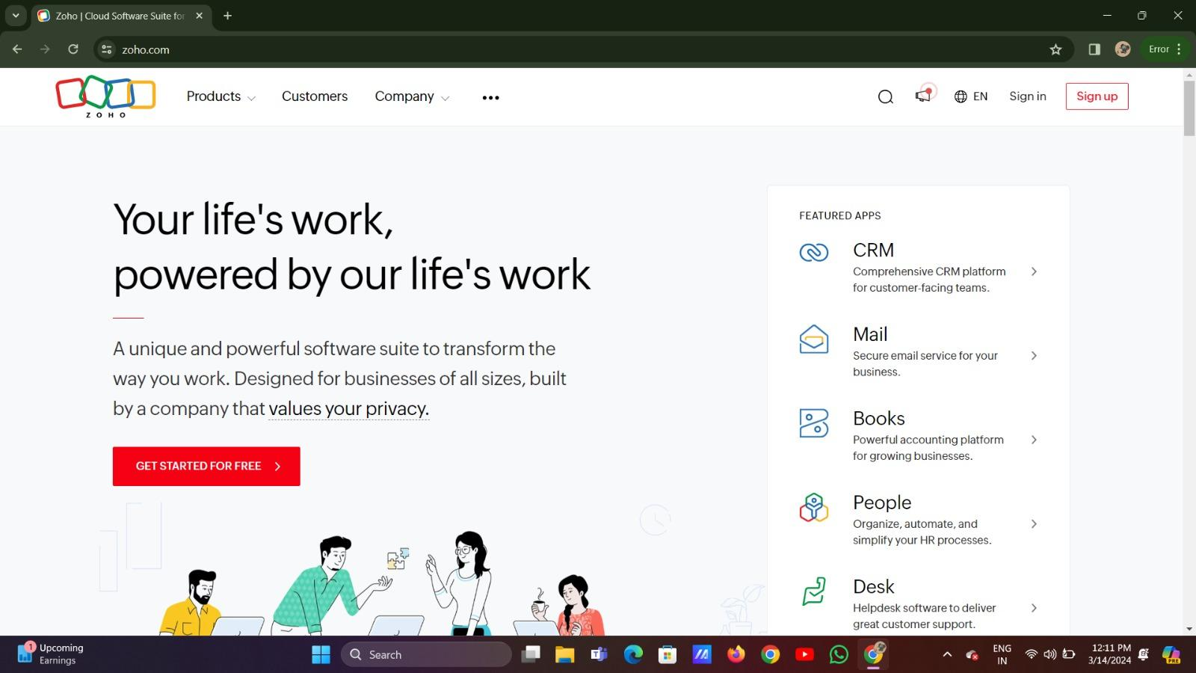

**2. Go to Creator**

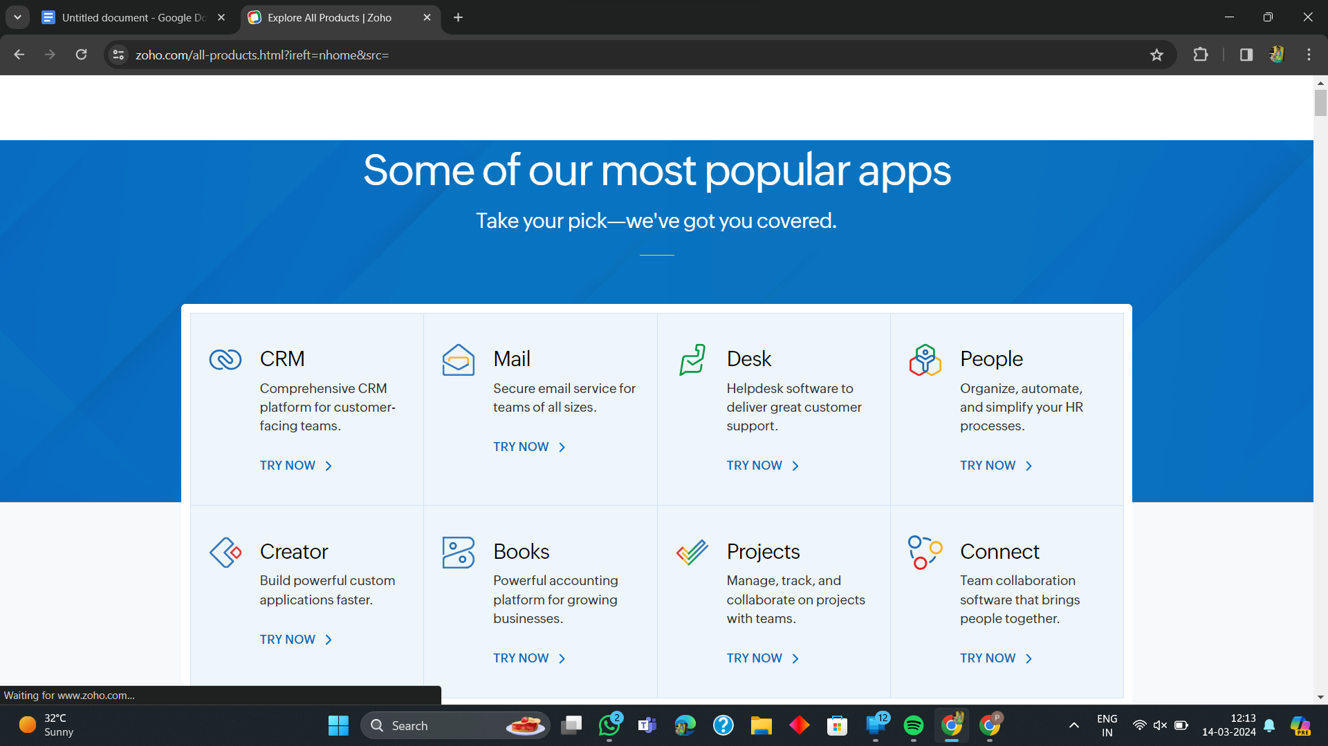

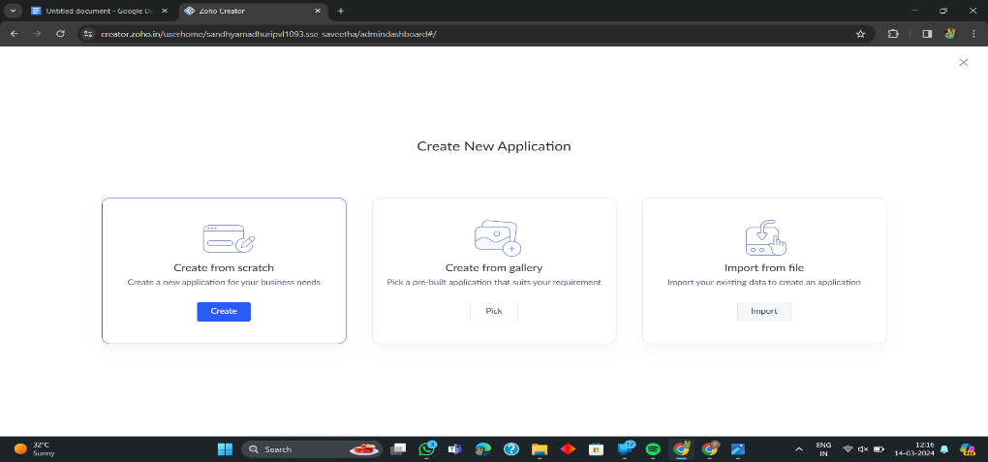**3. Create A New Application**

**4. Given Application Name**

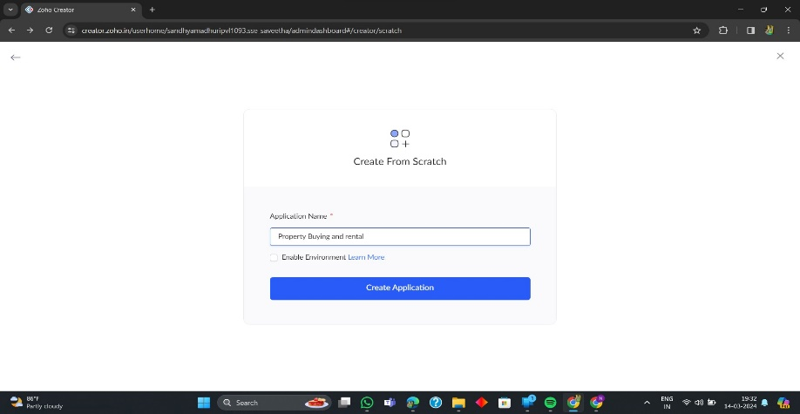

**5. Create New Form**

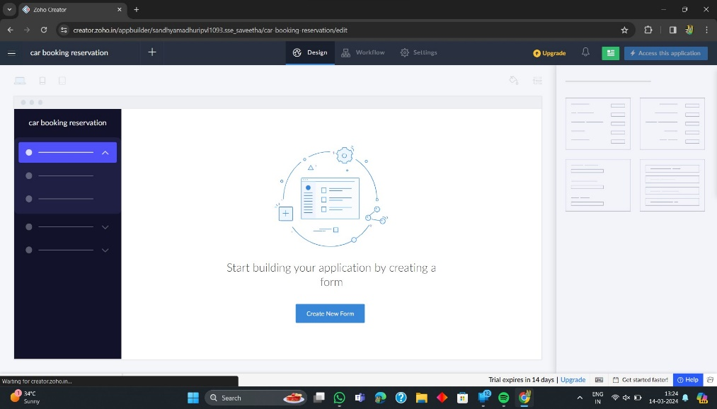

**6. Select Form and Give Name**

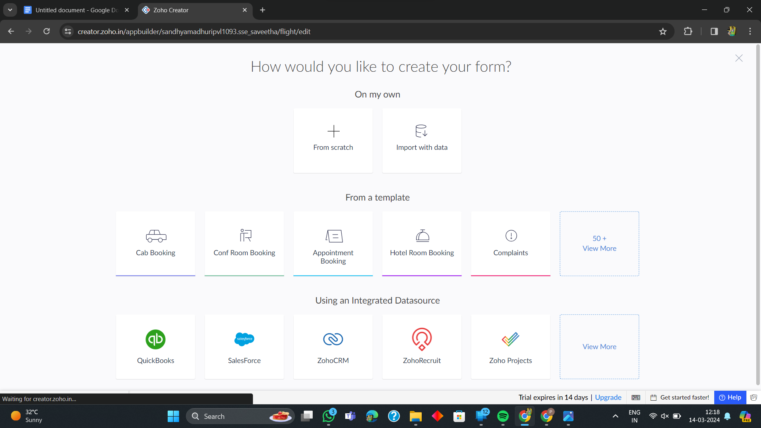

**7. Create from scratch**

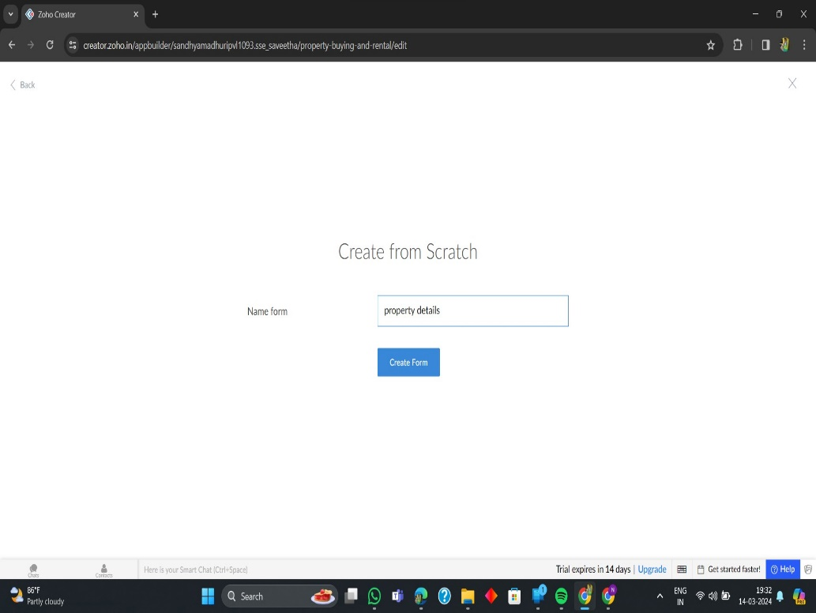

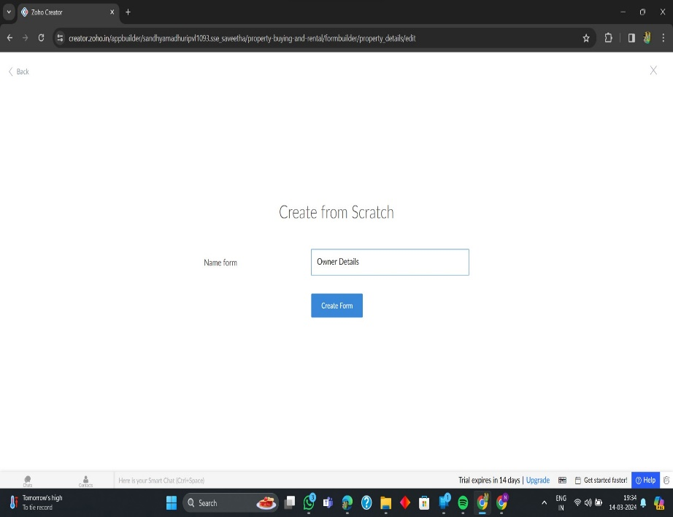

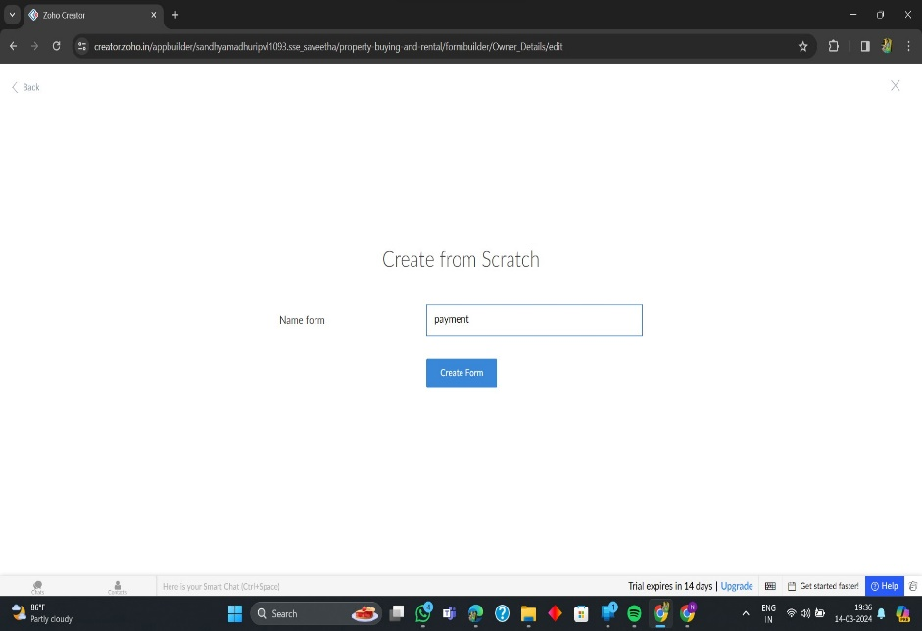

**8. The Software Has been created**

